**Name :**

**Hafsa Waseem**

**Roll no:**

**SU92-BSSEM-S24-014**

**Subject :**

**DSA (Lab)**

**Section :**

**3A**

**Submitted to:**

**Sir Rasikh**

**Task no 10:**

**Stack with linked list and array tasks .**

* **With Array ;**

**Push , pop, display**

* **With Linkedlist;**

**Push , pop , display**

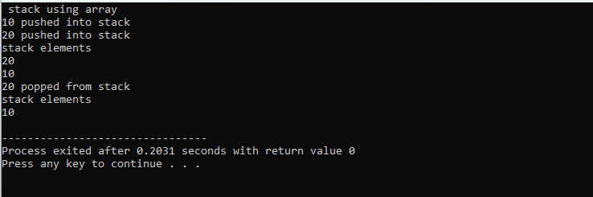

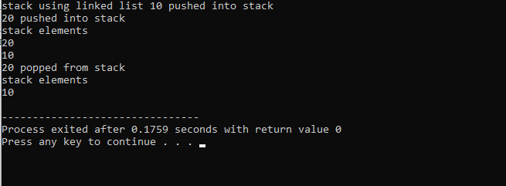

**Explain:**

In this code, we use a stack data structure, which works on the (LIFO) principle. We have shown two ways to build a stack one using an array and the other using a linked list. In both cases, we can push values onto the stack, pop values off the top, and display the stack contents. The array method uses a fixed size, while the linked list version is dynamic and can grow as needed. In the main function, the user picks which version to use, then the program pushes two numbers, shows the stack, pops one number, and shows the stack again.